A Quantitative Text Analysis of the Meanings of ‘Toxic Masculinity’ on Twitter

Alexandra Louise E. Enage

Victor Lorenzo B. Tirona

Ateneo de Manila University

A Quantitative Text Analysis of the Meanings of “Toxic Masculinity” on Twitter

Research Question: What are some meanings of “Toxic Masculinity” as captured on Twitter?

**Method**

**Data Collection**

The researchers made use of IFTTT, a free to use online service that logically connects different online platforms with each other. In this research’s case, Twitter, a social media platform mainly with text and images, was connected with Google Sheets, an office platform that organizes text via columns and rows. The researchers used IFTTT to collect tweets or text-based posts from Twitter users from the dates of January 31 to March 19, 2019. This collection amounted to over 28,564 text-based posts containing the words “Toxic Masculinity.” This collection was stored in a Google Sheets file along with various information related to the tweet such as the user name, the date and time of tweet, and the online link to the tweet.

**Data Cleaning**

For data cleaning, the researchers used two softwares to remove irrelevant data from the collection. A filtering function in Google Sheets was used to manually separate retweets from original tweets while multiple libraries were used in RStudio to remove functional words such as articles and prepositions.

On Twitter, there are two types of tweets that can be scraped: original tweets and retweets. Original tweets are text-based posts posted by users while retweets are produced from a user sharing an original tweet of another user. Retweets, while they can be shared out of positive affirmation, cannot immediately be interpreted as positive affirmation of the original tweet. Therefore, the researchers opted to remove the retweets and focus on interpreting the wider variety of meanings in the original tweets.

Each retweet that was scraped from Twitter began with the word “RT” in Google Sheets. This made it possible for the researchers to use Google Sheet’s filter function to alphabetize all posts and to separate all posts starting with “RT.”

Aside from removing the retweets, all columns were manually deleted except for the “tweet” column containing the tweet or text post of the users. This was done because the columns containing the usernames, date and time, and links were not going to be used in the data analysis.

Focusing on the sentence structure of the tweets, there are some words such as prepositions and articles that are mainly functional and provide no meaning to the researcher. These words, as they are in every sentence, dominate the more unique and descriptive words such as adjectives or nouns in terms of frequency. In order to avoid generating graphs that are dominated by these words, the researchers used RStudio to clean the data set from these words. This process will be discussed in further detail later in the section.

**Data Tidying and Analysis**

The researchers made use of RStudio to generate a graph based on the frequency of descriptive words attached to either “toxic” or “masculinity.” RStudio is a open-source IDE for R, a programming language that focuses on statistical computing and graphics. R provides a wide variety of functions and libraries that make it easy to manipulate data and output statistical graphs. This software was used both for cleaning and analysis of data. The following paragraphs will discuss the different packages and functions that were used to produce these graphs.

Among the 15 overall chunks of code, the first chunk loads various packages of additional functions that will be useful in data analysis. These packages are: dplyr, stringr, tidytext, tidyr, igraph, and ggraph.

The first two packages mainly deal with data handling and organizing. The package “dplyr” provides data manipulation functions such as mutate, select, and filter that help organize data. As the research mainly deals with words or strings of characters, packages like “stringr” provide functions that make it easy to manipulate and filter strings.

The next two packages mainly deal with data tyding and tokenization.The packages “tidytext” and “tidyr” contain functions such as separate, unnest, and unnest_tokens that allow for the tidying of data. This means that each relevant data point will be in its own individual row, column, and cell. Having separated and tidied data allows R to graph these data points easily.

The last two packages mainly deal with graphing the cleaned and tokenized data. The package “igraph” contains functions such as graph_from_data_frame() that organize data points from data frames into graphable tables of data. This is used in pair with the package “ggraph” which contains functions that control the color, text, form, and lines a graph uses.

The second and third chunks of code focuses on importing the tweets into R. First, the CSV file containing the tweets were imported into a table in R using the read.csv function. Second, the table was converted into a tbl_df. This class of data frame is compatible with data manipulating and data tidying packages to be used in succeeding chunks.

The fourth to tenth chunk of code focuses on tidying the data through stop word removal and tokenization. These chunks mainly use the dplyr, stringr, tidytext, and tidyr packages. The researchers created a custom list of stopwords through manually reading tweets and listing down usernames, slang, and various functional words. Using the tidytext package, each word in a given tweet was tokenized into its own row. This allowed R to compare the custom stop word list to each word in the tokenized table.

In order to create a graph containing words that appear right next to “toxic masculinity”, the tweets were broken down into consecutive pairings of words or bigrams. After the custom stop words were removed, the individual words were tokenized into bigrams with each word separated in different columns. This separation prepared the data for more cleaning. In the second round of cleaning, apart from the removal of generic stopwords, rare combinations of characters were also removed. This means that bigrams containing random letters such as “ujc3njxowo” would be removed from the data set. The end product for these chunks is a cleaned table of bigrams ready to be graphed.

The eleventh to fourteenth chunks focus on using the cleaned table of bigrams to produce a graph of the words that appear next to “toxic masculinity”. In order to reduce the data set only to the frequently used words, each unique bigram pair’s frequency was counted using R’s count function. After this, a subset of the table was made to contain only bigrams that have either of the words “toxic” and “masculinity”. Using the filter function, bigrams with frequencies less than 6 were removed. At this point, the table contained only meaningful words of high frequency. The data was ready to be graphed.

Using the function, graph_from_data_frame, the igraph package formatted the data set into a network with the words with the highest frequency as the nodes. In the data set, these would be toxic and masculinity as they are found in all tweets. The words attached to these nodes would be the bigram words that are of the highest frequency.

From this network, the ggraph function was used to represent the igraph network with the frequency “n” as a factor. Given ggraph’s functions, nodes were represented as points with text labels and were connected to each other based on frequency with colored lines. The end product was a graph with “toxic” and “masculinity” as nodes and different words connected to these nodes.

**Results**

The quantitative text analysis yielded four results. That is to say, our analysis focuses on the top 4 words most frequently used with the phrase “toxic masculinity” (see Figure 1). The top 4 words were as follows (from most frequent to less frequent): ‘fragile’, ‘male’, ‘white’, then ‘women’. Upon finding these top 4 words, the researchers looked for the tweets containing these very words in the raw data, and read through them to understand the context in which these words were being used. This allowed for an analysis of the ways these words were being used in discourse to give meanings to toxic masculinity. 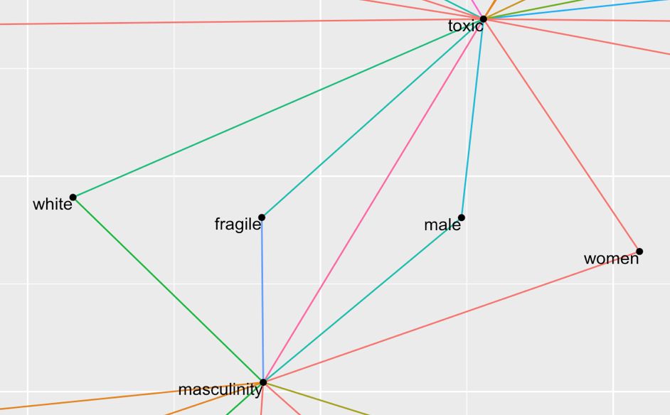

***Figure 1.*** Ggraph of the top four most frequent words that appeared with “toxic masculinity”

What the quantitative text analysis and subsequent analysis of raw data found was that there were two distinct ways in which toxic masculinity was being defined. The meanings placed upon toxic masculinity would change depending on whether context of the discourse called for the rejection or acceptance of toxic masculinity as a pressing societal issue.

**Women and Toxic Masculinity**

When rejecting the very existence of toxic masculinity, the meanings attached to it were often characterised by the use of the term “women”. When rejecting toxic masculinity, women were often blamed as being the reason toxic masculinity was created. Discourse indicated that toxic masculinity is a construct created by feminists who wanted special treatment. In this case, toxic masculinity was seen as a way for women to manipulate men’s behaviour to their liking. However, “women” was also often used when crafting examples of toxic masculine behaviours.

Often times, discourse placed women in the ‘victim’ role when faced with toxic masculinity. Trans women proved to be one common example being brought about in the discourse. It illustrated that one example of a toxic masculine behaviour is being unaccepting of trans women as real women, because some men are afraid of becoming attracted to a trans woman. Discourse indicated that people often confuse toxic masculinity with traditional masculinity. The term “women” was often used to provide examples that definitively set apart toxic masculinity from healthy masculinity. Traditional masculinity is being taught to respect everyone, women included. Toxic masculinity was depicted as being disrespectful towards women (e.g. sexual harassment as a power play). Emphasis was being placed on how traditional masculinity is not toxic masculinity, and often times, the term “women” was used to give concrete examples that set the two apart.

Moreover, “women” was used to emphasise that toxic masculinity as a social issue is not one that men alone should handle. Discourse indicated, through examples, that women, too, are capable of perpetuating toxic masculine behaviours. One example found in the discourse would be the story of a man getting a manicure at a salon, only to be pestered by the women there asking if he was gay. The fourth most frequent word, “women”, was the only one being used to argue both sides. That is, women were a constant part of the discourse surrounding toxic masculinity, whether it was to accept its prevalence as an issue, or deny its existence altogether.

**White, Male, and Toxic Masculinity**

Examining the raw data of toxic masculinity discourse allowed for the discovery of how “white” and “male” were often being used together. Further analysis of the context in which these terms were being used indicated that toxic masculinity was seen as a feature of white, patriarchal culture, and white privilege. Discourse indicated that toxic masculinity and white fragility come hand-in-hand.

Further analysis of the context in which “white” was being used indicated that its frequency in the discourse could not solely be attributed to toxic masculinity being seen as a part of white culture. White Ribbon Australia released a PSA entitled “Boys Don’t Cry” on February 26, and this sparked a conversation surrounding toxic masculinity. White Ribbon Australia is a non-profit organisation driven by the global White Ribbon Campaign, a campaign by men and boys working to end men’s violence against women. The discourse surrounding the PSA held a more positive public response. When making use of the terms “white” and/or “male”, toxic masculinity was given meanings attached to white, Western culture.

**Fragile and Toxic Masculinity**

The most frequently used word attached to “toxic masculinity” in the discourse was “fragile”. Further analysis of the contexts in which this word was being used indicated that it was being used as an equal to toxic masculinity. Toxic masculine behaviours were seen as a result of a fragile male ego or fragile masculinity. The two were often discussed interchangeably (e.g. “Toxic masculinity is fragile,” or, “Fragile masculinity is toxic.”). That “fragile” was the most frequently used term in toxic masculinity discourse is an indication of the commonality in attaching this particular meaning to toxic masculinity as a phenomenon.

Thus, analysis of the discourse surround toxic masculinity suggests that it is the result of the perpetuation of fragile, toxic masculine stands by men and women alike, and is considered a feature of white, patriarchal culture.